0.9 Clock & Reset
This is an important section because you've already used clock-related code in STM32CubeIDE without fully seeing what is happening underneath it.
Our target mental model is:
Clock source
↓
PLL / prescaler
↓
System clock
↓
Bus clocks
↓
Peripheral clocks
Let's build it from the ground up.

0.9.1 First: What is a clock?
A digital MCU needs a timing reference so its sequential logic knows when to change state.
Think of a clock as a repeating electrical signal:
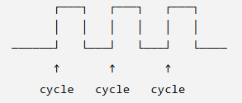
Each cycle provides timing for the digital system.
If the clock frequency is:
8 MHz
that means:
8,000,000 cycles/second
The period is:
$$T=\frac{1}{f}$$
So for 8 MHz:
$$T=\frac{1}{8,000,000}=125\text{ ns}$$
The important relationship:
Higher frequency → shorter clock period
Lower frequency → longer clock period

0.9.2 Where does the clock come from?
An MCU can have one or more clock sources.
For STM32F1, important ones include:
HSI
HSE
LSI
LSE
At our current level, understand their roles rather than memorizing every electrical specification.
HSI
High-Speed Internal clock
An oscillator integrated inside the MCU.
Advantage:
No external crystal required
HSE
High-Speed External clock
An external clock source, commonly provided by a crystal/resonator or external oscillator.
LSI
Low-Speed Internal clock
Used for low-speed functions such as the independent watchdog and related low-speed timing functions.
LSE
Low-Speed External clock
Typically associated with a 32.768 kHz crystal for accurate low-speed timing, especially RTC applications.
So conceptually:
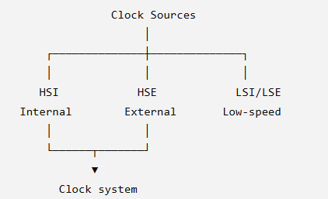

0.9.3 Why not just use one clock?
Because different parts of the MCU have different requirements.
For example:
CPU → high-speed operation
APB → peripheral bus
RTC → very low-speed accurate timing
Watchdog → independent timing
You don't necessarily want every block running from exactly the same clock at exactly the same frequency.
That's why STM32 has a clock tree.

0.9.4 The PLL
Now we reach an important component:
PLL = Phase-Locked Loop
One of its jobs in the STM32 clock system is to derive a higher-frequency system clock from an available clock source using configurable multiplication/division.
Conceptually:
HSE / HSI
│
▼
PLL
│
▼
Higher system-clock frequency
For example, conceptually:
8 MHz
↓
PLL
↓
72 MHz
The exact STM32F103 PLL configuration involves selectable source and multiplication factors. We'll calculate real configurations when we reach practical clock configuration.
Don't memorize "PLL always multiplies the clock." Think:
PLL is part of the clock-generation system used to derive the desired clock frequency.

0.9.5 System clock
Eventually, the clock system selects a clock that becomes the system clock, commonly referred to as:
SYSCLK
Conceptually:
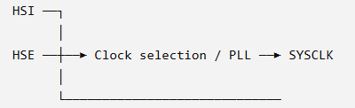
The Cortex-M CPU uses this system clock as the basis for its operating frequency.
For an STM32F103, the maximum system clock is 72 MHz for the relevant high-density/general F1 devices such as the F103C8. We will use the device documentation when we start configuring actual frequencies.

0.9.6 But SYSCLK isn't the end
This is where the bus material from 0.8 comes back.
We had:
CPU
↓
AHB
↓
APB1 / APB2
Now add clocks:
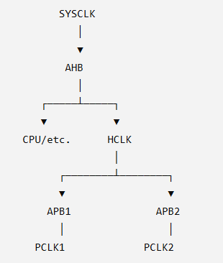
So:
SYSCLK
↓
AHB prescaler
↓
HCLK
↓
APB prescalers
↓
PCLK1 / PCLK2
This is the basic clock-tree relationship we wanted to understand.

0.9.7 What's a prescaler?
A prescaler divides a clock frequency.
For example:
72 MHz
↓
divide by 2
↓
36 MHz
So:
$$f_{out}=\frac{f_{in}}{N}$$
where N is the division factor.
This allows different sections of the MCU to operate at appropriate frequencies.

0.9.8 Why does this matter for GPIO?
Remember our earlier line:
RCC_APB2ENR |= (1 << 2);
We said this enables the GPIOA peripheral clock.
Now you can see the bigger picture:
Clock source
↓
Clock system
↓
SYSCLK
↓
AHB
↓
APB2
↓
GPIOA clock
↓
GPIOA can operate
So when you enable:
IOPAEN = 1
you're not creating a clock from nowhere.
You're allowing the already-established APB2 clock domain to reach GPIOA.
That distinction is important.

0.9.9 Clock frequency vs clock enable
These are two different concepts.
Clock frequency
Determines how fast the clock is running.
For example:
APB2 = 72 MHz
Peripheral clock enable
Determines whether a particular peripheral is being supplied with its clock.
For example:
RCC_APB2ENR |= (1 << 2);
means:
GPIOA clock = enabled
So:
Clock configuration
≠
Peripheral clock enable
They are related, but they're not the same operation.

0.9.10 Now RESET
Clock is only half of this section.
The other half is:
Reset
A reset puts the MCU or a peripheral into a known starting state.
Think about what would happen if you powered up a CPU and all its registers contained random values.
You couldn't reliably predict where execution starts.
Reset establishes a defined initial state.
Conceptually:
RESET
│
▼
CPU/peripherals
│
▼
Known initial state
│
▼
Start execution

0.9.11 Power-on reset
When the MCU initially receives power, the reset system ensures that the device starts in a controlled state.
Conceptually:
Power applied
↓
Reset circuitry
↓
CPU held/reset initialized
↓
Initial state established
↓
Execution begins
Later, we'll connect this directly to:
0.11 Startup Sequence
where you'll learn:

RESET
↓
initial SP
↓
Reset_Handler
↓
startup code
↓
main()

0.9.12 Peripheral reset
Reset doesn't only apply to the whole MCU.
Individual peripheral groups can also have reset controls.
For example, conceptually:
RCC
│
├── GPIO reset
├── USART reset
├── TIM reset
└── SPI reset
This allows a peripheral to be returned to its reset state without necessarily resetting the entire CPU.
This is another reason RCC is much more than "the clock register."
It manages important aspects of the MCU's clock and reset infrastructure.

The complete picture
Now combine 0.8 + 0.9:
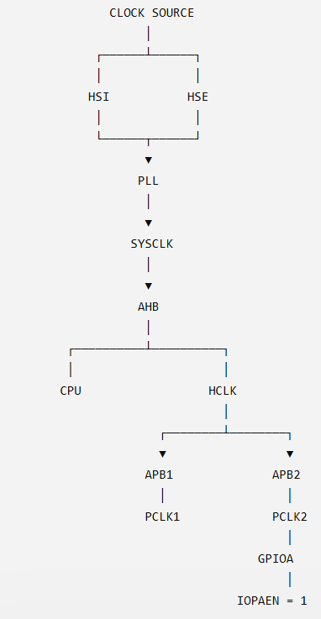
And separately:
RESET
│
▼
Known MCU state
│
▼
Startup sequence
│
▼
Program execution

🧠 Three distinctions I want you to remember
1. SYSCLK vs PCLK
SYSCLK → main system clock
PCLK → peripheral bus clock
2. Clock frequency vs clock enable
Frequency → how fast
Enable → whether the peripheral receives/uses its clock
3. Clock vs reset
Clock → provides timing
Reset → establishes/returns to a defined state
These three distinctions will save you a lot of confusion later.

Quick checkpoint
Only 4 questions:
Q1. If a clock is running at 72 MHz, what does that mean in terms of cycles per second?
Q2. What does a prescaler do to a clock frequency?
Q3. What's the difference between:
RCC_APB2ENR |= (1 << 2);
and configuring the APB2 clock frequency?
Q4. In one sentence, what is the purpose of reset?

Answers:
- when the frequency is high then the time period is low, it says that the clock is running at 72MHz speed of clock
- prescaler divides/muiltiplies the frequency in order to get our desired frequency/ clock cycle
- that line enables the clock to apb2 bus to gpioa and clock frequency is the speed of clock
- the purpose of reset is to clear the all registers and send them to their defined state

Good. Your understanding is mostly correct. There are two important corrections before we lock 0.9.
1. 72 MHz clock
Your idea is correct, but let's make the wording precise.
72 MHz means:
$$72 MHz=72,000,000 cycles/second$$
So the clock completes 72 million cycles every second.
And yes:
$$T=\frac{1}{f}$$
For 72 MHz:
$$T=\frac{1}{72×{10}^{6}}≈13.89 ns$$
So:
Higher frequency → shorter period → more clock cycles per second.

2. Prescaler
You said "divides/multiplies."
⚠️ Correction: A prescaler is fundamentally used to divide a clock frequency.
$$f_{out}=\frac{f_{in}}{N}$$
Example:
72 MHz
|
| APB prescaler ÷2
↓
36 MHz
A PLL can be used to derive a higher or otherwise different clock from a source. Don't mix PLL and prescaler.

3. RCC_APB2ENR |= (1 << 2)
Your basic idea is correct, but one wording needs fixing.
This line:
RCC_APB2ENR |= (1 << 2);
does not configure the APB2 frequency.
It enables the clock to GPIOA through the APB2 peripheral clock enable mechanism.
Think:
Clock configuration
↓
"What frequency is APB2 running at?"
↓
PCLK2

Clock enable
↓
"Is GPIOA allowed to receive/use its peripheral clock?"
↓
IOPAEN = 1
So these are two different jobs.

4. Reset
Your answer is good.
More precise version:
Reset puts the MCU or a peripheral into its defined reset state, so it starts from a known condition.
One small correction: reset does not necessarily mean every register becomes zero. Different registers can have different reset values.
For example, a register might reset to:
0x00000000
while another might reset to:
0x44444444
or some other defined value.
That distinction becomes important when we start doing register-level programming.

✅ 0.9 Clock & Reset: COMPLETE
You've got the core ideas:
- Frequency
- Period
- Clock sources
- PLL
- Prescalers
- SYSCLK
- HCLK/PCLK
- Peripheral clock enable
- Reset
LEVEL 0.9 COMPLETE ✅

🚀 LEVEL 0.10: Interrupt Fundamentals
Now we enter one of the most important concepts in embedded systems.
Imagine the CPU is doing this:
while (1)
{
do_something();
}
Meanwhile, an external event happens:
"UART received a byte!"
The CPU needs to react.
One approach would be:
while (1)
{
check_uart();
do_something();
}
This is polling.
But imagine having to constantly check:
- UART
- timer
- GPIO button
- ADC
- CAN
- sensors
- faults
The CPU would spend a lot of time asking:
"Anything happened?
Anything happened?
Anything happened?"
😵‍💫
That's where interrupts come in.
Basic interrupt idea
Instead of the CPU constantly checking:
CPU
|
| "Anything happen?"
| "Anything happen?"
| "Anything happen?"
the hardware can signal the CPU:
Peripheral/Event
|
| Interrupt request
↓
NVIC
|
↓
CPU
|
↓
ISR
Key terms
Interrupt:
A mechanism that temporarily redirects CPU execution to handle an event.
Interrupt request:
The signal/request generated when an interrupt-producing event occurs.
NVIC:
Nested Vectored Interrupt Controller. It is the Cortex-M interrupt controller responsible for managing many interrupts.
ISR:
Interrupt Service Routine. The function/code executed to handle the interrupt.
For example:
void EXTI0_IRQHandler(void)
{
// Handle interrupt
}
Don't worry about the exact STM32 interrupt names yet. We'll get there.
The mental model
Remember this:
Polling: CPU asks the peripheral whether something happened.
Interrupt: Peripheral tells the CPU that something happened.
That's the foundation of 0.10.
Quick checkpoint
- What is the main difference between polling and interrupt?
- If a timer reaches its configured value and generates an interrupt, what component receives/manages that interrupt before the CPU handles it?
- What does ISR stand for, and what is its purpose?

Answers:
- CPU asks the peripheral whether something happened is polling, Peripheral tells the CPU that something happened is interrupt
- nvic / cpu?
- interrupt service routine it executes the interrupt code
Exactly. You're getting the distinction correctly. Let's tighten Q2 and Q3.
1. Polling vs Interrupt ✅
Perfect:
Polling: CPU asks the peripheral, "Did something happen?"
Interrupt: Peripheral signals the CPU, "Something happened."
That's the fundamental difference.

2. NVIC / CPU? ✅
NVIC is the correct answer.
The simplified flow is:
Timer event occurs
↓
Timer generates interrupt request
↓
NVIC
↓
CPU
↓
ISR executes
The NVIC manages the interrupt request before the CPU executes the handler.
Think of NVIC as the traffic controller for interrupts. 🚦
It can manage things such as:
- Which interrupt is pending
- Interrupt priority
- Enabling/disabling interrupts
- Nested interrupts

3. ISR ✅
Correct.
ISR = Interrupt Service Routine
It is the code/function that handles the interrupt event.
For example:
void TIM2_IRQHandler(void)
{
// Handle timer interrupt
}
The important idea is:
Event
↓
Interrupt request
↓
NVIC
↓
CPU changes execution flow
↓
ISR
↓
Return to previous program
One important detail for later: the ISR itself isn't "the interrupt." It is the handler code executed because of the interrupt.

✅ 0.10 Interrupt Fundamentals COMPLETE
You now have the core chain:
Event → Interrupt Request → NVIC → CPU → ISR
Next is 0.11 Startup Sequence.
This one is particularly important because it answers a question most beginners skip:
When you power on an STM32, how does the CPU actually get from reset to main()?

We'll trace:
Power ON / Reset
↓
Stack Pointer
↓
Reset Handler
↓
Startup Code
↓
System Initialization
↓
main()
And we'll connect this directly to the startup_stm32f103xb.s file you see inside CubeIDE.

